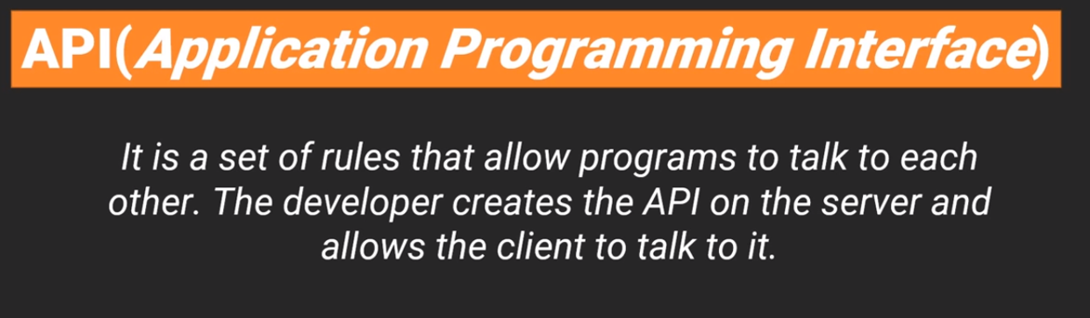

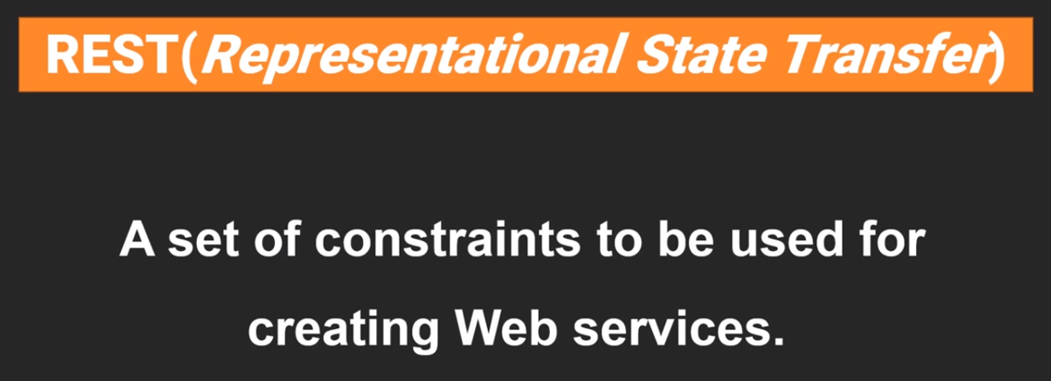

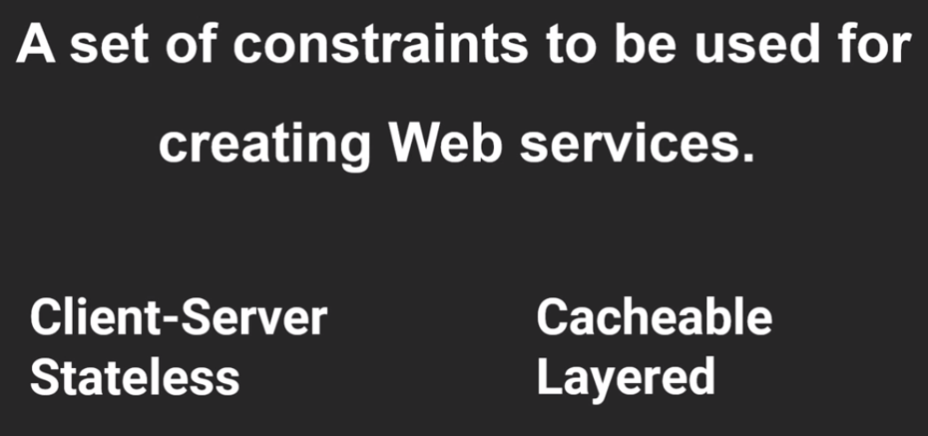

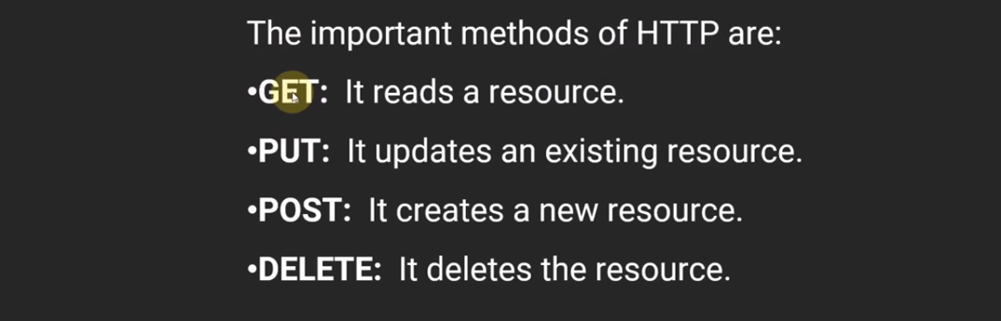

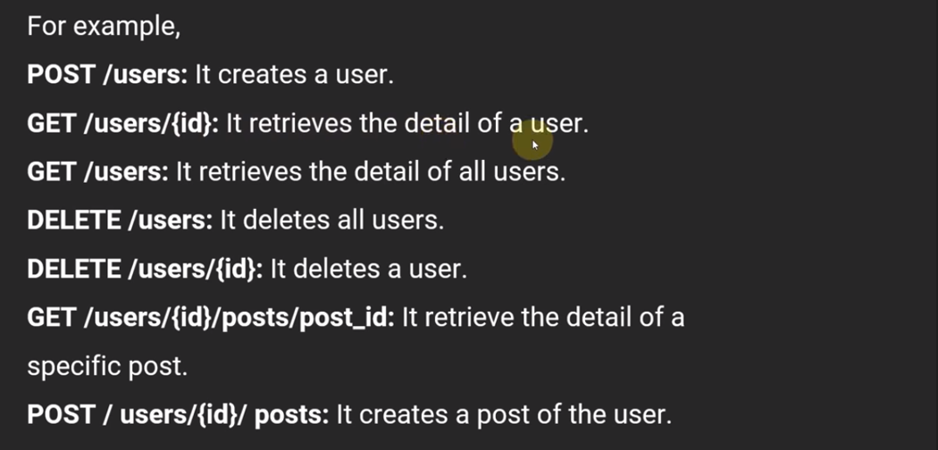

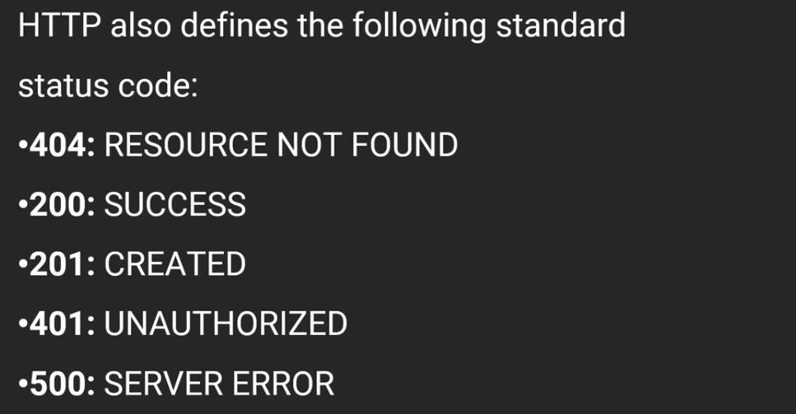

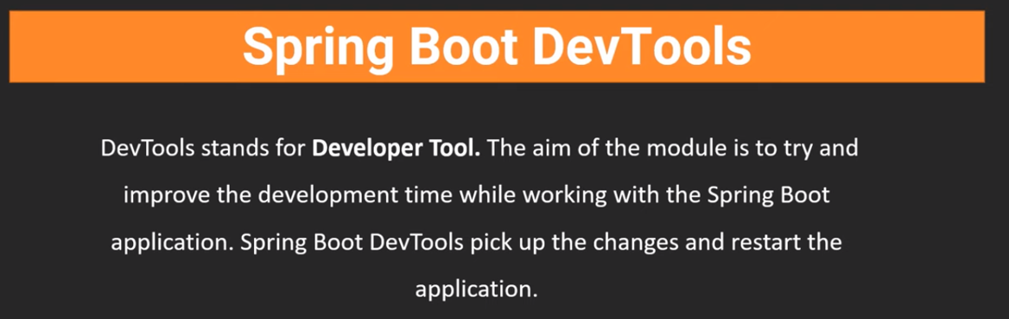

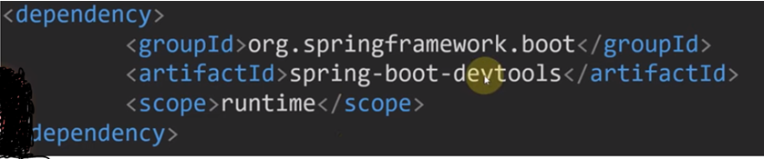

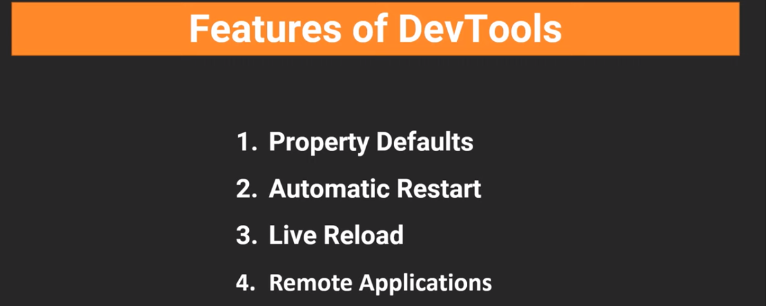

**Sample Spring Web Application to show the working of ‘Spring Boot Dev Tools’ working:**

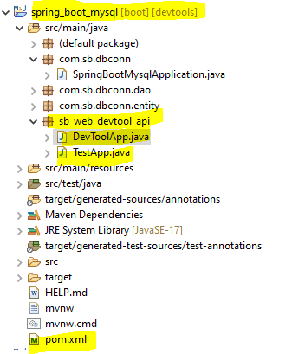

Add the following ‘dependency’ to the pom.xml file:

**<dependency>**

**<groupId>org.springframework.boot</groupId>**

**<artifactId>spring-boot-starter-web</artifactId>**

**</dependency>**

**<dependency>**

**<groupId>org.springframework.boot</groupId>**

**<artifactId>spring-boot-devtools</artifactId>**

**<scope>runtime</scope>**

**<optional>true</optional>**

**</dependency>**

TestApp.java:

**package sb_web_devtool_api;**

**import org.springframework.stereotype.Controller;**

**import org.springframework.web.bind.annotation.RequestMapping;**

**import org.springframework.web.bind.annotation.ResponseBody;**

**@Controller**

**public class TestApp {**

**@RequestMapping("/test")**

**@ResponseBody**

**public String getResult() {**

**int a = 100;**

**int b = 230;**

**return "Addition result of a and b is: " + (a+b);**

**}**

**}**

Main class:

**package sb_web_devtool_api;**

**import org.springframework.boot.SpringApplication;**

**import org.springframework.boot.autoconfigure.SpringBootApplication;**

**import org.springframework.context.ApplicationContext;**

**@SpringBootApplication**

**public class DevToolApp {**

**public static void main(String[] args) {**

**ApplicationContext context = SpringApplication.*run*(DevToolApp.class, args);**

**System.*out*.println(context);**

**System.*out*.println("Application Started !!!");**

**}**

**}**

Console Output:

**2023-11-02T10:25:19.893+05:30[0;39m [32m INFO[0;39m [35m3188[0;39m [2m---[0;39m [2m[ restartedMain][0;39m [36m.ConditionEvaluationDeltaLoggingListener[0;39m [2m:[0;39m Condition evaluation unchanged**

**org.springframework.boot.web.servlet.context.AnnotationConfigServletWebServerApplicationContext@1b874e77, started on Thu Nov 02 10:25:18 IST 2023**

**Application Started !!!**

**[2m2023-11-02T10:25:26.497+05:30[0;39m [32m INFO[0;39m [35m3188[0;39m [2m---[0;39m [2m[nio-8080-exec-1][0;39m [36mo.a.c.c.C.[Tomcat].[localhost].[/] [0;39m [2m:[0;39m Initializing Spring DispatcherServlet 'dispatcherServlet'**

**[2m2023-11-02T10:25:26.497+05:30[0;39m [32m INFO[0;39m [35m3188[0;39m [2m---[0;39m [2m[nio-8080-exec-1][0;39m [36mo.s.web.servlet.DispatcherServlet [0;39m [2m:[0;39m Initializing Servlet 'dispatcherServlet'**

**[2m2023-11-02T10:25:26.503+05:30[0;39m [32m INFO[0;39m [35m3188[0;39m [2m---[0;39m [2m[nio-8080-exec-1][0;39m [36mo.s.web.servlet.DispatcherServlet [0;39m [2m:[0;39m Completed initialization in 6 ms**

**[2m2023-11-02T13:28:18.404+05:30[0;39m [33m WARN[0;39m [35m3188[0;39m [2m---[0;39m [2m[l-4 housekeeper][0;39m [36mcom.zaxxer.hikari.pool.HikariPool [0;39m [2m:[0;39m HikariPool-4 - Thread starvation or clock leap detected (housekeeper delta=3h28s726ms764µs500ns).**

**[2m2023-11-02T14:06:07.108+05:30[0;39m [33m WARN[0;39m [35m3188[0;39m [2m---[0;39m [2m[l-4 housekeeper][0;39m [36mcom.zaxxer.hikari.pool.HikariPool**

Output from Browser:

